STAT 112 - Introduction to Data Processing and Visualization Project

The Geographical and Economic Distribution of G-7 Nations.

By

Sumeya Mohamed Muse.

December -1,2024

Abstract.

This research is about the geography and economics of G-7 countries. The G-7 countries are Japan,France,Germany,UK,USA,Italy,Canada.For me to achieve the required research questions and required precise data tidying and cleaning in order to use the datasets. It was essential to join the datasets for me to achieve the economic and the relationship between the G-7 countries. The result of our research questions on the clean data, we interpreted and analyzed relationship between sever categorial and numerical data.

Introduction.

This research I prepared and analyzed datasets. After join my datasets using left join ,my dataset contains 36 variables but for my research questions ,my dataset contain 9 variables .Main goal in this project was to know how the G-7 countries interaction and interpret this variables ,and also obtain their unique relationships. The dataset contain 9 field ;

Ordernumber: Discrete data

Quantityordered: Continuous data. The sum of sales in G-7 countries.

Sales: Continuous data. The average of sales in G-7 countries

Productline: Discrete data.

Country: Discrete data.

Birth Rate : Continuous data. The average of birth rate in G-7 countries

Gasoline Price: Continuous data. The sum and average of gasoline price in G-7 countries.

Unemployment rate: Continuous data. The average of number of unemployed rate in G-7 countries.

# Data Tidying and Cleaning.

In the process of data tidying and cleaning. When joining the datasets some of the data change data types using tableau clean my datasets and set the data types to be right one on each variable. There were no missing value in the dataset.

Research Questions.

1. What are the top ten product lines, and which G-7 countries are they purchased from?
2. What is the relationship between gasoline prices and unemployment rates across G-7 countries?
3. What is the relationship between gasoline price in G-7 countries?"
4. Which specific product lines are ordered more in urbanized countries?
5. What is the distribution of birth rates across G-7 countries?

Exploratory Data Analysis.

1. What are the top ten product lines, and which G-7 countries are they purchased from?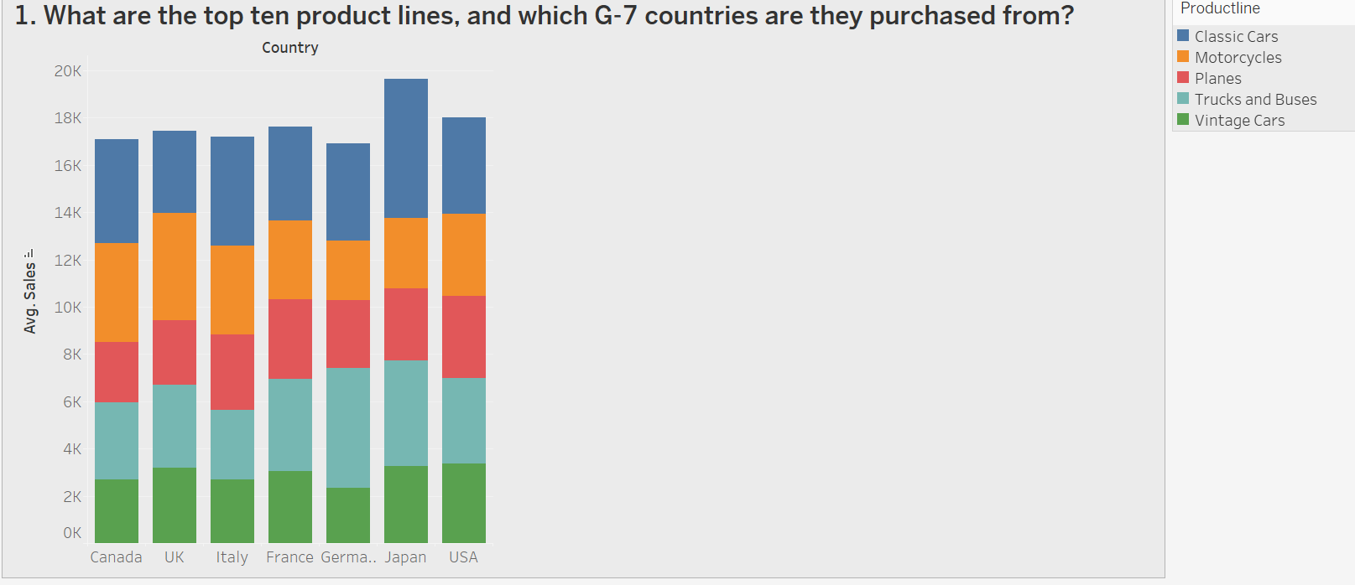

The country variable is dimension ,which is on the x-axis. The sales variable is continuous data ,using the sales average which start from 0k-20k on y-axis. The third variable is productline which is dimension data ,using the filter to filter the top 10 product using the filter to filter the G-7 countries. To know the relationship between the three variables and make easy for me to interpret my question I used stacked bar chart.

The country Japan had the highest average sales in the total of the G-7 countries,also it had the had purchased the classic cars the most throughout the sales. The Japan people love the classic cars more while the Germany people love trucks and buses .The UK purchase motorcycles the most then the other productline. The plane was the same for each country and there is only slightly different only.

2.What is the relationship between gasoline prices and unemployment rates across G-7 countries?

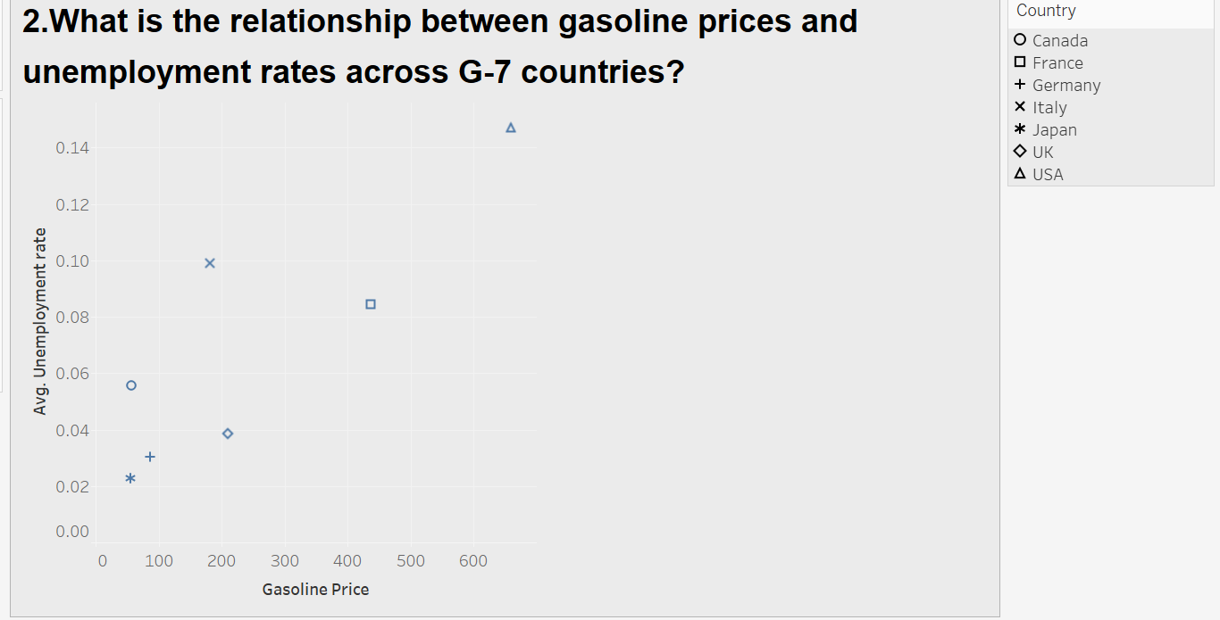

The unemployment rate is continuous data, using the average of the unemployment rate on the y-axis. The gasoline price is continuous data ,using the sum of the gasoline price on the x-axis. The country variable to filter the g-7 countries. To know the relationship between the variables using to represent my question visualization, I used scatter plot to know the relationship between the gasoline price and unemployment rate and the country which has the highest unemployment rate and also high gasoline prices.

The USA had the highest unemployment rate and also gasoline prices while Japan had the lowest unemployment rate and also gasoline price were low. The Italy and France had slightly different between each other.

3.What is the relationship between gasoline price in G-7 countries?"

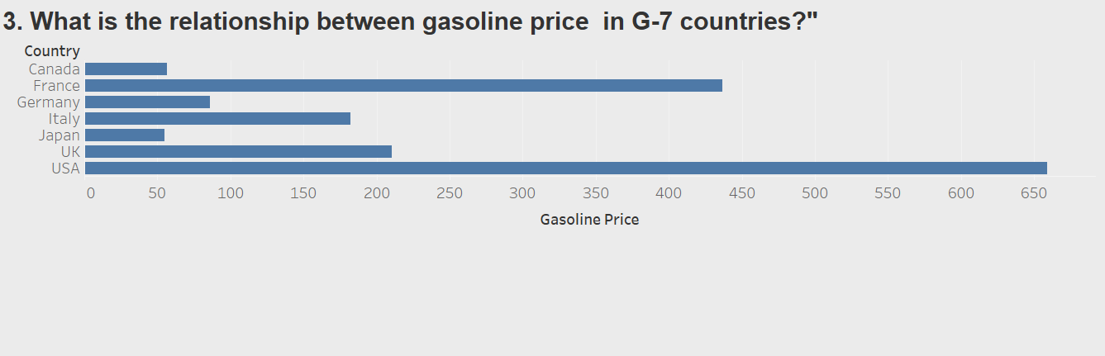

The gasoline price is continuous data, using the sum of gasoline price on y-axis. The country is discrete data, using to filter the G-7 countries . To know the relationship between the two variables, I used bar graph to visualize it easily.

The Gasoline price is high in USA as the price is 600 while Japan had the cheapest price in all the G-7 countries. Canada was next in the cheapest price in all the countries while France had also had the second expensive after the USA.

4.Which specific product lines are ordered more in urbanized countries?

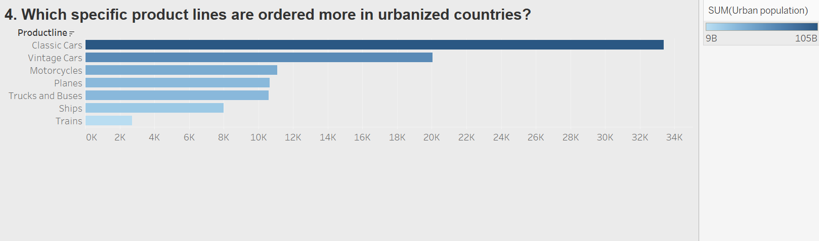

The quality Order is continuous data, using the sum of quality Order is on y-axis. The productline is discrete data, using to filter the top productline. The Urban population is continuous data, using the sum of urban population to in marks color, the dark the color goes the high the population. To know the unique relationship between the variables, I used bar graph to visualize.

Most urban populations spend more on classic cars than trains . The most purchased product is classic cars while the least purchased is trains. Planes and trucks and buses have the same purchased quality order.

5.What is the distribution of birth rates across G-7 countries?

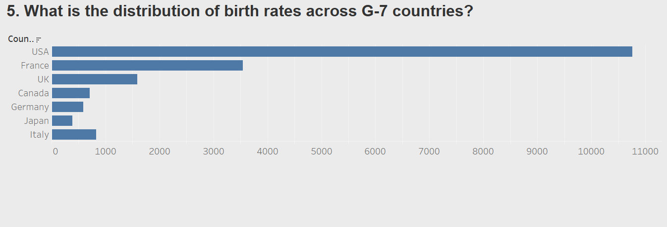

The birthrate is continuous data ,using the sum of the birthrate on the y-axis. The country is discrete data, using the to filter the G-7 countries . To know the relationship between these variables. I used the Bar graph to visualize it.

The USA has the highest birthrate compared to other G-7 countries. Japan has the lowest birthrate compared to other G-7 countries while Canada and Germany have slightly different from each other.

# Conclusion.

In conclusion, in my project analysis, interpretation and questionnaire. The country USA had the worst economic and the population was the highest. The other countries in the G-7 countries had the best economic and normal population. To increase the economy in the USA we should growth the rate of employment and reduce the birth rate, also for the economy to be okay we must create a way of reducing the gasoline price maybe by using the train more than classic cars. Then the G-7 countries’ economy and geography will be okay .

<https://dub01.online.tableau.com/#/site/sumeyamuse-2df1f9e630/workbooks/2139294?:origin=card_share_link>